LAB-1
By R.Sabarinath
Batch-5
1.Ping to 50.0.0.10 from 50.0.0.20
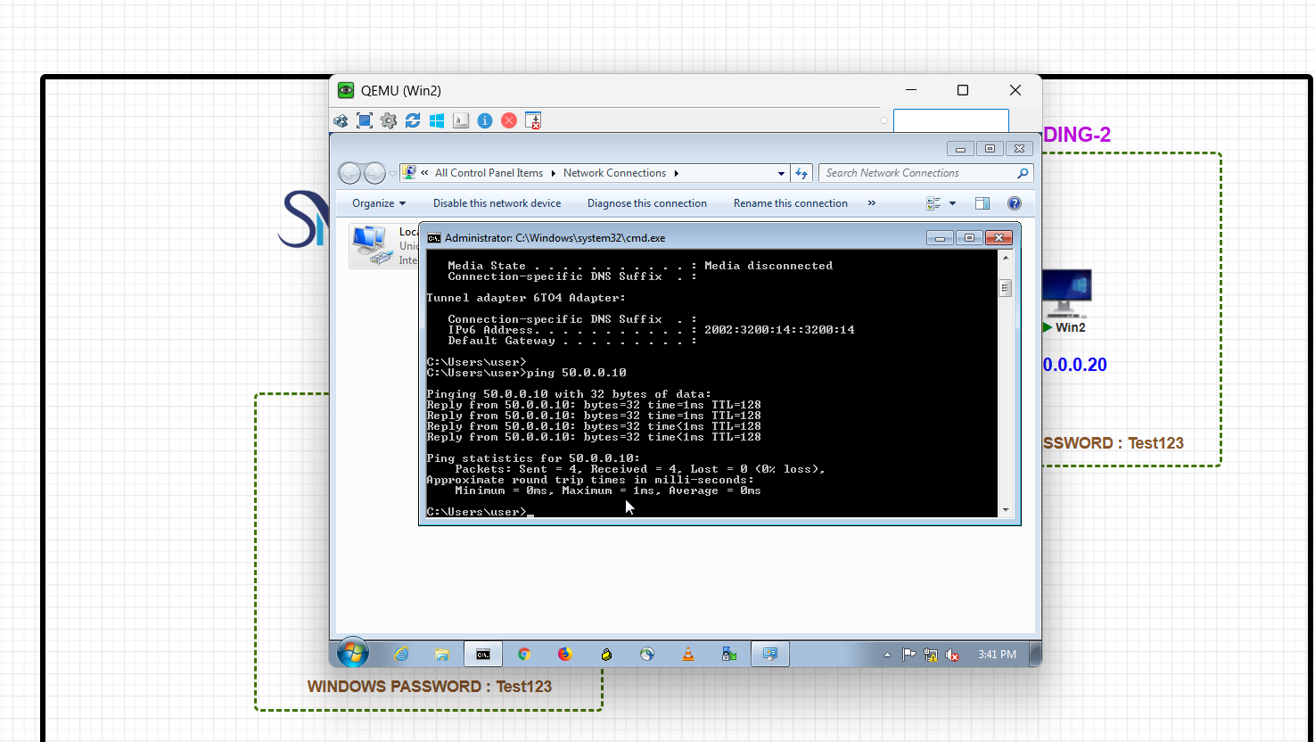
2.After Assigning the System Name connect sys2 from sys1
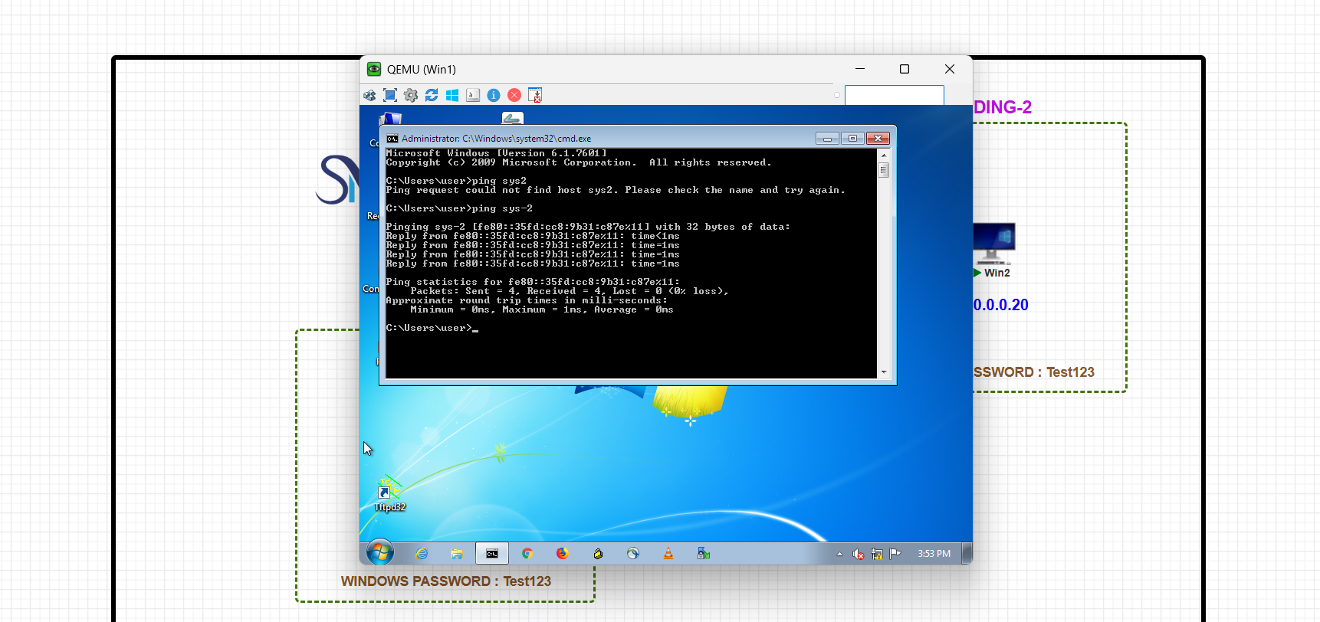
3.File Trasnfer via IP
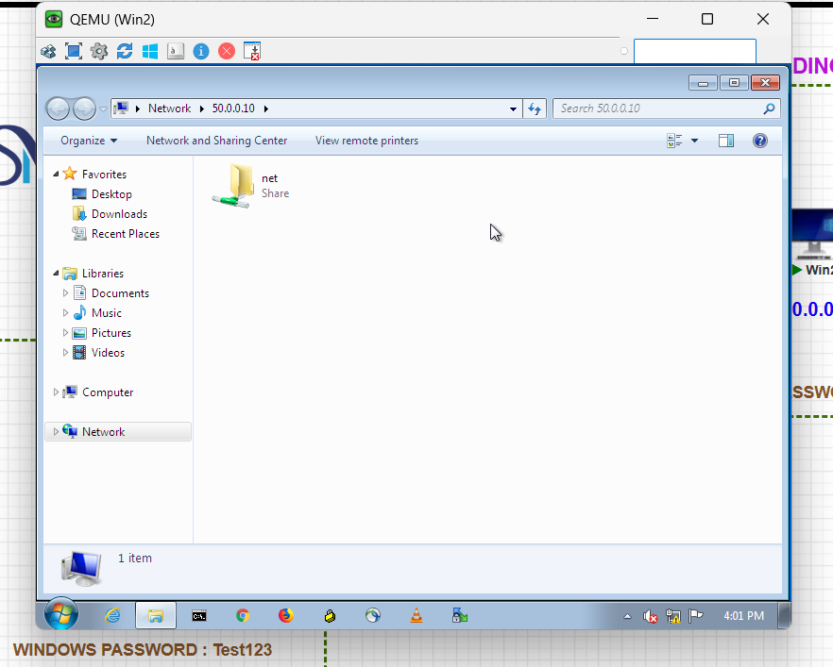
4.Remote Desktop
